**Omar Raza CS250-L02**

**Lab 2**

1. **In-Lab Assignment:**

Part 2:

1. When the potentiometer was turned to the left, LED1 lighted up slowly, while when it is turned to the right LED2 quickly lighted up.
2. ‘f’ does show digital behavior

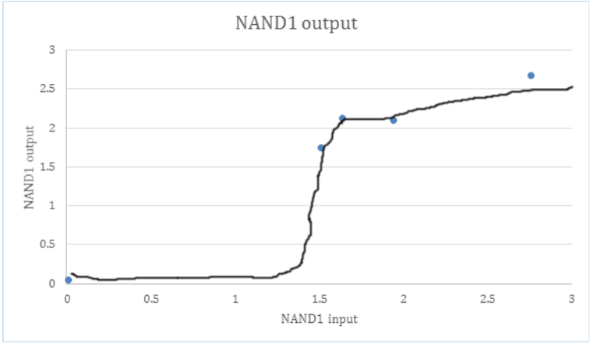

it has a very quick transition from 0 to 2.5, which means that all possible noise is being flushed out, resulting in digital behavior

1. NAND1 uses amplification. This is important because there will never be an input of perfectly logic 0 or 1, so amplifying the input will make sure that noise doesn’t create errors.
2. When the button is pushed, it is open, the resistance is that of air, which gave a reading of **.9*200M** which is extremely high, and for the purposes of a circuit, it is like infinity. When it isn’t pushed, and it is closed, the resistance is **0**.
3. Where all bounces are in mod 16

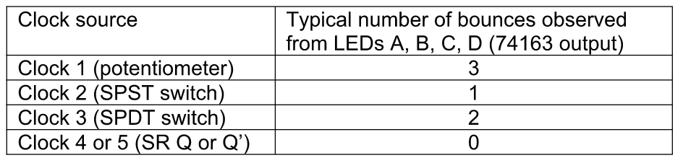

1. If it is currently displaying 7, or 7mod16, adding anything that is a subset 2mod16, i.e. 18mod16, 34mod16, will result in it displaying 9
2. **Take Home:**